SOLUTION: Take-Home: Quiz 7 (15 pts) – Inheritance in C++

Part I: Short Answer.

1. (5 pts) What is inheritance? Explain.

The ability of a class (derived) to derive properties from a previously defined (base) class. The derived class customizes the properties of the base or acquired class. It’s considered a form of software or code reuse.

Part II: Fill-In-The-Blank.

2. (2 pts) Inheritance enables _________code reuse (just reuse is ok)_____________, which saves time in development and encourages using previously proven high-quality software.

3. (2 pts – 1 pt/each) An object of a(n) __________derived______________ class can be treated as an object of its corresponding _______base_________ class.

4. (2 pts) Inheritance is representative of a(n) _______is-a(n)_________ relationship. A Manager object demonstrates this relationship because it can be treated as an Employee object.

5. (2 pts) The following class diagram is an example of _____multiple______ inheritance.

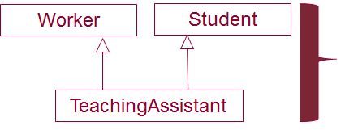

6. (2 pts) When an object of a derived class is instantiated, the base class’ _______constructor_________ is called implicitly or explicitly to initialize the data members of the base-class in the derived-class object.

