CptS 121 - Program Design and Development
Lab 4: Wonderful World of "if" Statements in C

Assigned: Week of February 9, 2026
Due: At the end of the lab session

I. Learner Objectives:

At the conclusion of this programming assignment, participants should be able to:
Compose decision statements ("if" conditional statements)
Create and utilize compound conditions

II. Prerequisites:

Before starting this programming assignment, participants should be able to:
Open and close files
Read, write to, and update files
Manipulate file handles
Apply standard library functions: fopen (), fclose (), fscanf (), and fprintf ()
Implement and apply predicate functions
Discover and distinguish between characters and how they are represented
- Handle the 3-file format/organization including: 1 header file, and 2 source
files
Distinguish between formal parameters and actual arguments
Apply appropriate actual arguments to function calls as test inputs

III. Overview & Requirements:

This lab, along with your TA, will help you navigate through applying selection statements in C. Once again, we will take a modular approach to designing solutions to the problems below. As part of the lab, you will need to decide which C selection structure is best suited for a particular problem. You will use "if" statements. For this lab you should NOT use generative AI.

Labs are held in a “closed” environment such that you may ask your TA questions. Please use your TAs knowledge to your advantage. You are required to move at the pace set forth by your TA. You are required to work in teams of 2-4 students. Please help other students in need when you are finished with a task. Have a great time! Labs are a vital part of your education in CptS 121 so work diligently

Tasks:

Work in your teams!

- Write a Calorie Calculator program to determine what a person's caloric intake should be for a 24-hour span. The program must decide about caloric intake, to maintain current body weight, based on gender, age, weight, and height, and activity level. Before you implement any code, you must draw a flowchart on the whiteboard. Below is the start of flowchart that will help you with this program:
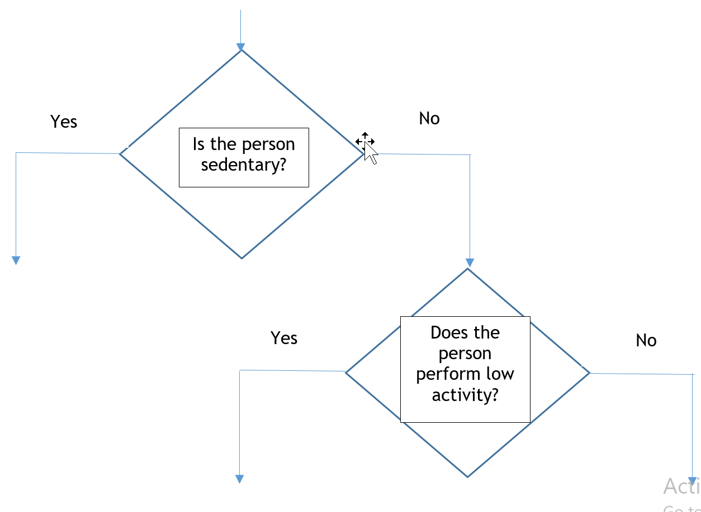

- The Program must first compute the Basal Metabolic Rate (BMR). The BMR formula is the following:

Women: BMR = 655 + (4.35 * weight in pounds) + (4.7 * height in inches) - (4.7 * age in years)
Men: BMR = 66 + (6.23 * weight in pounds) + (12.7 * height in inches) - (6.8 * age in years)

To determine total daily calorie needs, your program must apply the following guidelines:
1. Sedentary (little to no exercise): Calories = BMR * 1.2
2. Low activity: Calories = BMR * 1.375
3. Moderate activity: Calories = BMR * 1.55
4. High activity: Calories = BMR * 1.725
5. Extra activity: Calories = BMR * 1.9

Define functions where appropriate! Also, read age, gender, weight, and height values from a file. How should you arrange the data in your .txt file to represent each of the values? The way you organize the file will directly impact the way your program reads the data from the file. Be very meticulous with the organization of your .txt file!

2. Write a program to determine a professional baseball player's bonus at the end of a season. The bonus is calculated as follows:
1. All-Star Game appearance = $25,000
2. Regular season MVP = $75,000
3. World Series MVP = $100,000
4. Gold Glove award = $50,000
5. Silver Slugger award = $35,000
6. Home run champ = $25,000
7. Batting average champ = $25,000

Prompt the user with a question related to each of the above categories. If the response is 'y' for yes, add the bonus to the total, otherwise if the response is 'n' move to the next question. Use functions where appropriate.

3. Write a program which reads five numbers from a file and performs one of the following operations on those numbers:
1. Average
2. High value
3. Low value

Your program must display a menu with the above options. Display the result to the screen.

IV. Submitting Labs:

- You are not required to submit your lab solutions. However, you should keep them in a folder that you may continue to access throughout the semester.

V. Grading Guidelines:

- This lab is worth 10 points. Your lab grade is assigned based on completeness and effort. To receive full credit for the lab you must show up on time, work with a team, complete at least two-thirds of the problems, and stay until the TA has dismissed you.

