EE334 Computer Architecture Spring 2012

Branch Target Buffer Project

For this project you are going to simulate a branch target buffer (BTB). You are going to write a program that simulates a BTB. The figure below shows the basic structure of the BTB; this buffer was presented in class.

Current PC Predicted PC Prediction Busy

10

PC

: : : :

Below are some of the ***minimum*** requirements for your BTB:

* BTB size: 1K entries (1024 entries)
* Input file: text file with addresses in hexadecimal (0,1,2,3,4,5,6,7,8,9,a,b,c,d,e,f)
* Four benchmark program traces must be run
* Implement at least one 2-bit branch predictor.
* Compare performance when *not taken branches* are and are not kept in BTB. You have that to get into the BTB a branch has to be taken.
* Output: number of right and wrong predictions (accuracy), and hit rate.

Teams will consist of two students per team.

**Email (**[**jdelgado@eecs.wsu.edu**](mailto:jdelgado@eecs.wsu.edu)**) names of the members of the team by April 9**

**Mid-project report due: April 20, 2012 at 5PM (email submission) (see page 3)**

**Project report with all the results is due on May 4 at final exam (see page 4)**

400190

400194

400198

40019c

4001a0

4001a4

4001a8

4001ac

Current PC Target PC Prediction Busy

4001c4 4202b0 Taken Y

4202dc 42ac30 Taken Y

: : : :

4001b0

4001b4

4001b8

4001bc

4001c0

**4001c4**

4202b0

4202b4

4202b8

4202bc

4202c0

4202c4

4202c8

4202cc

4202d0

4202d4

4202d8

**4202dc**

42ac30

42ac34

42ac38

42ac3c

42ac40

42ac44

42ac48

42ac5c

42ac60

42ac64

42ac68

42ac6c

42ac70

42ac74

42ac78

42ac7c

42ac80

42ac84

42ac88

42ac8c

42ac90

42ac94

42ac98

42ac9c

42aca0

42aca4

**EE334 Spring 2012**

**Mid-Report Report Due: April 20, 2012**

The purpose of this report is to check if your simulator is adding branches to the branch target buffer (BTB) in the proper places.

1) Run your simulator using the file tracefile which contains just over a large number of addresses.

2) Please report the following:

a) Total number of taken_branches or jumps that were found.

b) Print the entries in the BTB that have a branch. Include the address of the branch and target address. Prediction will be incorporated later.

c) Number of times the branches were found in BTB. This will provide information about the hit rate. The hit rate will be small, the sample is small.

**EE334 Computer Architecture Spring 2012**

**Project Report Due: May 4, 2012**

Please include the following items in your report:

1. Introduction

Brief description of the problem (i.e. Branch instructions and their impact on performance).

Brief description of your project

1. Parameters that are set and observed
   * 3 Benchmarks (sample trace is not considered a benchmark)
   * Hit rate
   * Prediction accuracy (or miss prediction)
2. Result of the simulations

Please use graphs and tables (don’t include just data)

1. **Discussion of results**

Please describe in detail your findings (use a quantitative approach to discuss the impact of your findings)

-impact on CPI ?

1. References/bibliography

Find some good references at: http://ieeexplore.ieee.org

There several traces that are located at: **http://www.eecs.wsu.edu/~jdelgado/traces/For your information and potential use**

There are other 2-bit predictors as shown below. These predictors have shown to be good for some benchmarks.

For your project you could use one of the 2-bit predictors (or use the one in the textbook)

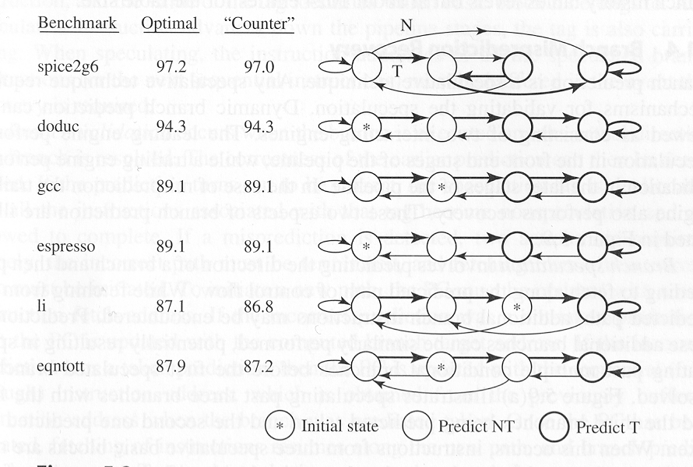

*

Predictor

**A**

**B**

**C**

**D**

**E**

**F**