EE334 Spring 2011
Project Report Due: May 3, 2011

Please include the following items in your report:

- Introduction
Brief description of the problem (i.e. Branch instructions and their impact on performance).
Brief description of your project

- Parameters that are set and observed
  - 2 different 2-bit predictors
  - BTB size (1024 entries.)
  - 3 Benchmarks (sample trace is not considered a benchmark)
  - Hit rate
  - Prediction accuracy

- Result of the simulations
Please use graphs and tables (don’t include just data)

- Discussion of results
Please describe in detail your findings (use a quantitative approach to discuss the impact of your findings)
-impact on CPI ?

- References/bibliography
Find some good references at: http://ieeexplore.ieee.org

EE334 Spring 2011

For your project you will compare three different predictors. There are six predictors below; these predictors have shown to be good for some benchmarks as shown in the figure.
For your project you should choose 2 predictors.

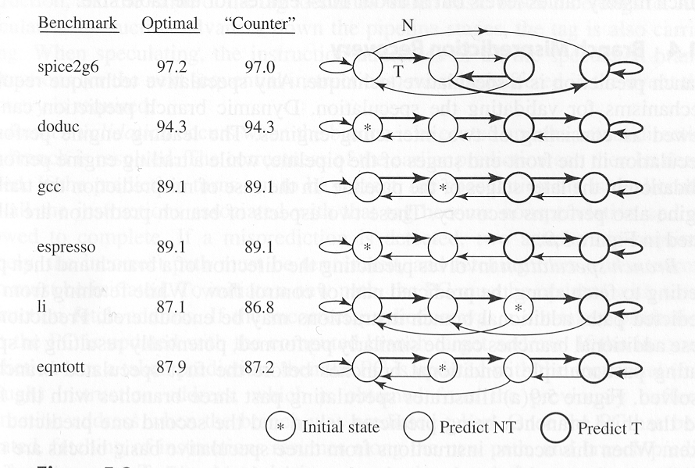
Predictor

A

B

C

D

E

F
*

